Introduction

Superconductivity occurs in certain material at low temperatures which conducts electricity perfectly without any resistance. In 1962 David Josephson predicted pairs of electrons now known as cooper pairs can quantum tunnel/travel across a gap separating two superconducting materials without applying a voltage *[1].* The *supercurrent* created is known as the DC Josephson Effect; he also predicted that an AC supercurrent can also be observed by applying small amounts of voltage. The Josephson Effect has wide range of applications in measuring weak magnetic fields along with calculating precise measurements of e/h.

When a material becomes superconducting, the electrons form [Cooper pairs](javascript:page('supra-explication-cooper',false)) and condensate in the shape of a unique[collective quantum wave](javascript:page('supra-explication-condensat',false)). If the electric insulator separating the two superconductors is very thin (only a few nanometres), then the wave can somehow spill out of the superconductor, which enables the [electron pairs](javascript:page('supra-explication-cooper',false)) to go through the insulator thanks to a quantum effect called tunneling effect. When spontaneously going from one superconductor to the other, the pairs create an electric current. Each superconductor is characterized by a quantity called phase, with a subtle signification. The electric current in the junction is a continuous current, the value of which is proportional to the sine of the phase difference between the two superconductors.

Now, if we apply a constant electric tension difference between the two superconductors, an alternating electric current appears, in reaction to the phase variations. This effect that links a continuous voltage to an alternating current is unusual. Especially since the frequency of alternating currents depends neither on the size of the superconductors, nor on their properties (critical temperature, chemical composition). This frequency only depends on the applied voltage and on fundamental permanent features (the electric charge of the electron and Planck quantum of energy). We can measure a frequency very precisely thanks to atomic clocks, but until this effect was discovered, we could not precisely measure a voltage. The Josephson effect enables us to define a reference value of the voltage that is then used to calibrate the measuring devices and to make sure that one volt has the same value in France and in Japan.

Josephson effects are very sensitive to the value of the magnetic field, because the phase variation of a superconductor can be linked to the magnetic flux. It then becomes possible to use this magnetic field sensitivity to build very accurate magnetic field measuring devices, called [squids](javascript:page('applications-squid',false)): these devices are the most precise means to measure a magnetic field.

*[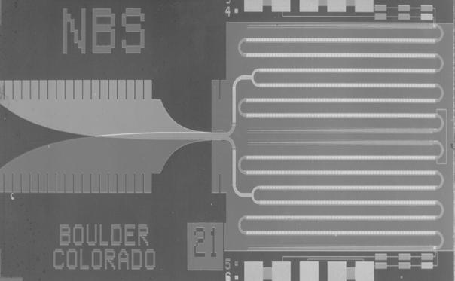](http://www.supraconductivite.fr/media/images/Applications/image033.jpg)This*

1. <http://physics111.lib.berkeley.edu/Physics111/Reprints/JOS/04-The_Josephson_Effects.pdf>
2. <http://physics111.lib.berkeley.edu/Physics111/Reprints/JOS/Clark_Josephson_effect_andeh.pdf>